Parrot Mini Drone

Group 24

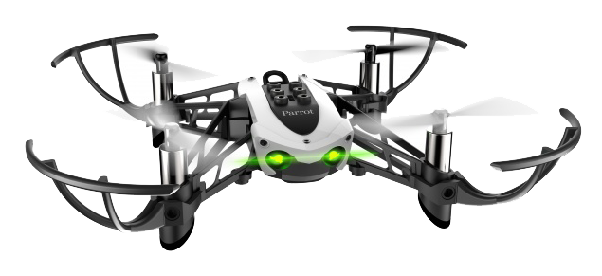

School: Fontys University of Applied Science

Program: Electrical Engineering

Course: Model Based System Engineering (MBSE)

Members: Afonso, Yongjie, Raphael, Ahmad

Table of Contents

1. Introduction 3

2. Goal of the project 3

3. Description of the system 3

3.1 Functionality 3

3.2 Requirements 3

4. SysML diagrams 3

4.1 Structure Diagrams 3

4.2 Behavior Diagrams 3

5. MATLAB explanation 3

5.1 General system 3

5.2 Flight control system 3

6. Test plan 3

6.1 Simulation 3

6.2 Drone 3

7. Conclusion 3

8. Recommendations 3

9. References 3

# Introduction

# Goal of the project

# Description of the system

## Functionality

## Requirements

# SysML diagrams

Requirement diagram

## Structure Diagrams

Block definition diagram

Internal block diagram

## Behavior Diagrams

Activity diagram

Use case diagram

# MATLAB explanation

## General system

## Flight control system

Waypoint follower

# Test plan

## Simulation

## Drone

# Conclusion

# Recommendations

# References